Customer Behavior Analysis
Varsha Patil¹, Akshara Sarode² ,
Nikita Chaudhari³ , Kaustubh Sonawane⁴, Samyak Badkul^{5,}

¹²³⁴⁵ Computer Engineering Department, SIES Graduate School of Technology, Mumbai, University of Mumbai, India

{varshap, aksharasce120, nikitacce120, kaustubhsce120, samyakbce120)@gst.sies.edu.in
Abstract. Understanding customer behavior and providing personalized recommendations play a pivotal role in enhancing user engagement and satisfaction on e-commerce platforms. In this paper, we leverage the Amazon Food Dataset to conduct a comparative analysis of recommendation systems using a diverse array of algorithms. Specifically, we evaluate the performance of recommendation systems through Mean Squared Error (MSE) and Confusion Matrix metrics, focusing on the following algorithms: Random Forest Regressor, distance-based models with cosine similarity, Singular Value Decomposition (SVD), matrix factorization techniques, Probabilistic Matrix Factorization, Convolutional Neural Networks (CNNs), stacked Long Short-Term Memory (LSTM) networks, and attention-based autoencoders. Our analysis aims to shed light on the strengths and limitations of each algorithm in capturing user preferences and providing personalized recommendations. Furthermore, the integration of deep learning techniques, including CNNs, stacked LSTM networks, and attention-based autoencoders, presents promising avenues for enhancing recommendation accuracy and capturing intricate user-item interactions. These deep learning architectures demonstrate capabilities in capturing spatial and temporal patterns within the data, thereby offering personalized recommendations tailored to individual user preferences. Through our comparative analysis, we seek to offer insights into recommendation system performance across various algorithms, guiding future research toward improving accuracy and personalization in e-commerce. Our results deepen understanding of customer behavior analysis and offer valuable direction for optimizing recommendation systems to enhance user experience.
Keywords: Recommendation system, Matrix Factorization, SVD, CNN, Stacked LSTM, Attention-based autoencoder.

- Introduction
The project focused on leveraging Amazon data underscores the crucial role that e-commerce platforms and user feedback play in influencing consumer decisions. Aimed at refining the accuracy and effectiveness of recommendation systems, this initiative sought to provide personalized product suggestions to users through the application of various advanced techniques, including Matrix Factorization, Singular Value Decomposition (SVD), Random Forest Regressor, Convolutional Neural Network (CNN), Stacked Long Short-Term Memory (LSTM), and attention-based autoencoders.

By comparing and integrating these diverse methods, the project aimed not just to enhance functionality of existing recommendation systems but also to extend their relevance across different e-commerce scenarios. The effectiveness of a recommendation system is pivotal, as accurate product recommendations serve multiple strategic business objectives: they can significantly increase revenue by better identifying user demand and facilitating targeted marketing strategies; additionally, they improve customer retention rates by fostering long- term relationships through enhanced user satisfaction. Beyond commercial implications, the project addressed broader issues such as the challenge of information overload in the digital age. Despite the advances made by traditional models in recommendation systems, they often fall short when handling large or dynamically changing datasets, or when needing to adapt to new user preferences quickly. These limitations catalyzed the project's focus on developing more robust and scalable algorithms capable of managing diverse and extensive datasets effectively.

This endeavor is not just a technical upgrade; it's a strategic move towards understanding deeper user behavior and preferences. By exploring novel methodologies and algorithms, the project aimed to pave the way for the development of more sophisticated, effective, and ethically sound recommendation systems. These systems promise to empower users with better choices and drive business success, marking a significant step forward in the utilization of digital technology to enhance both user experience and business outcomes in the digital age.

2 Review of Literature

In their research, Ruslan Salakhutdinov and Andriy Mnih tackle the challenges posed by existing collaborative filtering methods when dealing with large datasets and users with sparse ratings. They introduce the Probabilistic Matrix Factorization (PMF) model, which offers linear scalability with the number of observations and excels in performance on the Netflix dataset, known for its sparsity and imbalance. Additionally, the authors extend the PMF model by incorporating an adaptive prior on model parameters, enabling automatic control of model capacity. They also propose a constrained version of PMF based on the assumption that users with similar movie preferences rate similar sets of movies, thus enhancing generalization, especially for users with limited ratings. By combining predictions from multiple PMF models with those from Restricted Boltzmann Machines, they achieve a noteworthy error rate of 0.8861, surpassing Netflix's own system by nearly 7%. [2]

Lekshmi Priya, T., Sandhya, H. in the year 2021 suggested Recommendation systems (RS) are pivotal for predicting user preferences across various items. Traditionally, RS leverages collaborative filtering, content-based filtering, or a hybrid combination of both techniques to generate recommendation lists. However, each method faces distinct challenges such as cold-start, data sparsity, scalability issues, processing streaming data, and ensuring low latency. Moreover, the dynamic nature of user preferences due to frequent data updates necessitates the generation of fresh recommendation lists based on recent activity, thereby accommodating concept shifts and eliminating outdated item preferences. To address these challenges, we propose a solution based on matrix factorization, which proves to be robust and capable of handling sparse and streaming data effectively. In this approach, user preferences are represented in matrix format and decomposed into smaller matrices to facilitate interpretation and information retrieval. Empirical analysis employing four matrix factorization techniques—NMF, NMFALS, CUR, and SVD—indicates that SVD outperforms the others in terms of both time efficiency and recommendation accuracy, making it an optimal choice for robust RS implementations. [6]

This paper of respective authors A. Agarwal and Senthilkumar have explored various recommendation techniques aimed at simplifying and expediting recruitment processes. It involves classifying candidates based on job descriptions and assessing the match percentage of their resumes with job requirements. Only resumes with a minimum 50% match proceed in the recruitment process. Leveraging classification techniques helps overcome these challenges, improving recruitment efficiency. By automating screening, these techniques save resources and enhance the experience for both the company and candidates. This research aims to contribute to more effective and seamless recruitment processes, ultimately benefiting company operations. [9]

In response to the escalating demand for personalized recommendations within Social Web applications, particularly in the domain of online learning, A. K. Dey, V. K. Chauhan, P. K. Singh, and P. Choudhury delve into the realm of artificial intelligence-driven recommendation systems. While previous research has extensively explored the application of diverse machine learning and neural network techniques for suggesting research materials to online learners, conventional algorithms often fall short when confronted with the challenge of processing large-scale data. Consequently, they are deemed inadequate for generating personalized recommendations within learning systems. In their study, the authors propose an innovative LSTM-based approach tailored specifically to analyze the behavioral patterns of online learners and forecast their interests accurately. To evaluate the effectiveness of their proposed method, the researchers plan to validate its performance using various performance metrics such as accuracy, precision, recall, and F1 score, providing valuable insights into its potential for generating relevant learning recommendations. [10]

In recent years, the integration of deep neural networks into recommendation systems has led to remarkable advancements in performance across various tasks. However, Q. Li, X. Zheng, and X. Wu identified several critical issues in existing models that combine deep learning with recommendation tasks. These challenges include the inability to handle both explicit and implicit feedback due to specialized network structures, the underutilization of deep learning's expressive potential in explicit models, and the tendency of neural network models to overfit in implicit settings. To address these issues, the authors introduce a pioneering recommender framework known as Neural Collaborative Autoencoder (NCAE). NCAE effectively captures intricate hidden relationships between interactions through a non-linear matrix factorization process, making it adaptable to both explicit and implicit feedback scenarios. Furthermore, the authors develop a comprehensive three-stage pre-training mechanism to optimize NCAE's deep architecture by combining supervised and unsupervised feature learning. To counteract overfitting in implicit settings, they propose an error reweighting module and a data-augmentation strategy that is aware of sparsity. Extensive experiments conducted on real-world datasets showcase the significant advancements achieved by NCAE, surpassing existing state-of-the-art methods. [11]

3 The Proposed Method
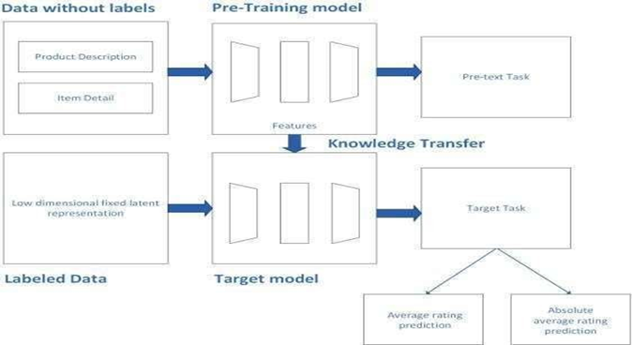

Figure 1: The proposed system diagram.

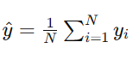
The Random Forest Regressor is an ensemble learning method that constructs a multitude of decision trees during training and outputs the average prediction of the individual trees for regression tasks. The algorithm works by randomly selecting subsets of features and data points to build each tree, thereby reducing overfitting. The predicted output (ŷ) for a given input vector (x) in the Random Forest Regressor can be expressed as follows:

(1)

Where (N) is the number of decision trees in the forest, and y{i} is the output of the (i th) decision tree.

In Distance-based model, cosine similarity is employed to measure the similarity between two vectors by computing the cosine of the angle between them. Given two vectors (u) and (v), the cosine similarity (cosine_similarity) can be calculated as:
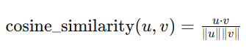

(2)

Where (u.v) represents the dot product of vectors (u) and (v), and (|| u ||) and ( || v ||) denote the norms of vectors (u) and (v), respectively.

SVD is a matrix factorization technique that decomposes a matrix (X) into three matrices (U), (Σ), and (V^T), where (U) and (V) are orthogonal matrices, and (Σ) is a diagonal matrix containing the singular values. Mathematically, SVD can be represented as:
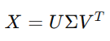

(3)

Where (X) is the original matrix, (U) contains the left singular vectors, (Σ) contains the singular values, and (V^T) contains the right singular vectors.

Matrix Factorization aims to decompose a user-item interaction matrix into two low-rank matrices, representing users and items, respectively. The predicted rating r{ij} for user (i) and item (j) can be computed as:
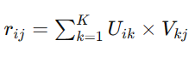

(4)

Where (U) and (V) are the user and item matrices, and (K) is the number of latent factors.

Probabilistic Matrix Factorization extends matrix factorization by modeling the observed ratings as samples from a Gaussian distribution. The likelihood function for the observed ratings R can be defined as:
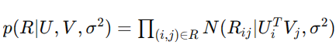

(5)

Where U{i} and V{j} are the latent factor vectors for user (i) and item (j), respectively, and (Σ) represents the variance.

In CNNs, convolutional layers are employed to extract features from input data through convolution operations followed by non-linear activation functions such as ReLU. Mathematically, the output of a convolutional layer (H) can be computed as:
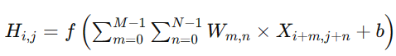

(6)

Where (f) represents the activation function, (W) denotes the convolutional filter weights, (X) is the input matrix, and (b) is the bias term.

LSTM is a type of recurrent neural network that is capable of learning long-term dependencies. Attention-based autoencoders extend traditional autoencoders by incorporating mechanisms that focus on relevant parts of the input data. The equations governing LSTM and attention mechanisms are complex and involve multiple components such as input, forget, and output gates, as well as attention weights and context vectors. These equations are typically expressed in terms of matrix operations and non-linear activation functions, facilitating the modeling of sequential data with long-range dependencies.

Each of these algorithms offers unique advantages and complexities, catering to different aspects of recommendation systems and customer behavior analysis. By comprehensively understanding their mathematical underpinnings, researchers and practitioners can effectively leverage these algorithms to optimize recommendation performance and enhance user experience in e-commerce platforms.

4 Results
The customer behavior analysis project conducted a thorough comparison of recommendation systems using various algorithms on the Amazon food dataset, employing evaluation metrics such as MSE, confusion matrices, and accuracy. Findings revealed that the Random Forest Regressor demonstrated moderate predictive capability, yielding an MSE of 0.4890 and an accuracy of 0.7666, while the Distance-based model with Cosine Similarity exhibited a higher MSE of 2.303 and a lower accuracy of 0.4482. Singular Value Decomposition (SVD) and Matrix Factorization emerged as top performers, showcasing strong performance with low MSEs of 0.207 and 0.0265, respectively, alongside high accuracies of 0.9405 and 0.8656. Additionally, Probabilistic Matrix Factorization demonstrated commendable performance with an MSE of 0.02806 and an accuracy of 0.8323. Convolutional Neural Networks (CNN) displayed moderate predictive capability with an MSE of 1.167 and an accuracy of 0.723. Notably, the Stacked Long Short-Term Memory (LSTM) and Attention-based Autoencoder achieved remarkable accuracy of 0.9936, although a specific MSE value was not reported. In summary, SVD emerged as particularly effective, closely followed by Matrix Factorization, while LSTM and Attention-based Autoencoder exhibited high precision in recommendation.

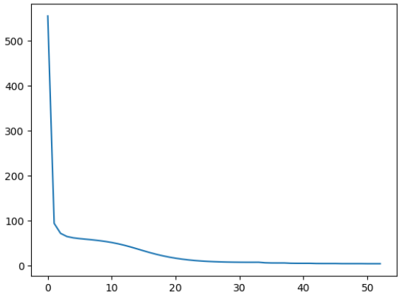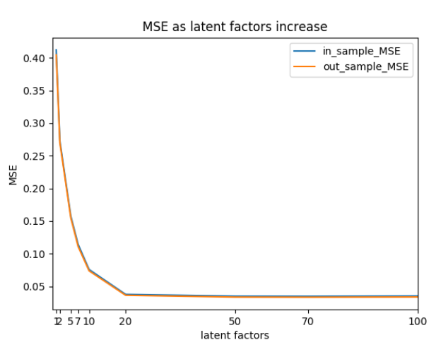

Figure 5: Evaluation Graph of (i) Matrix Factorisation
(ii) Probabilistic Matrix Factorisation

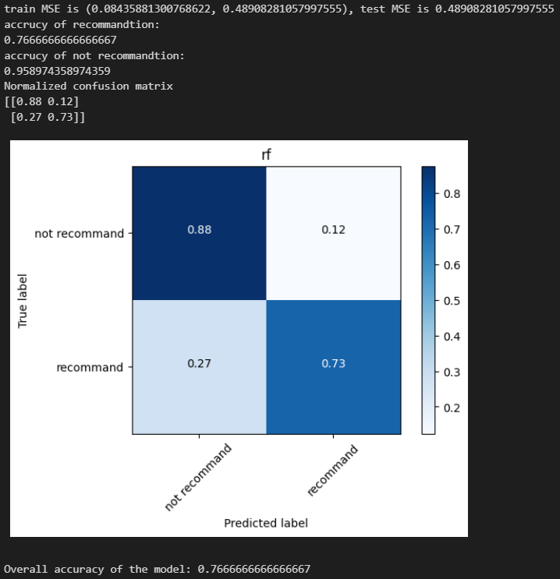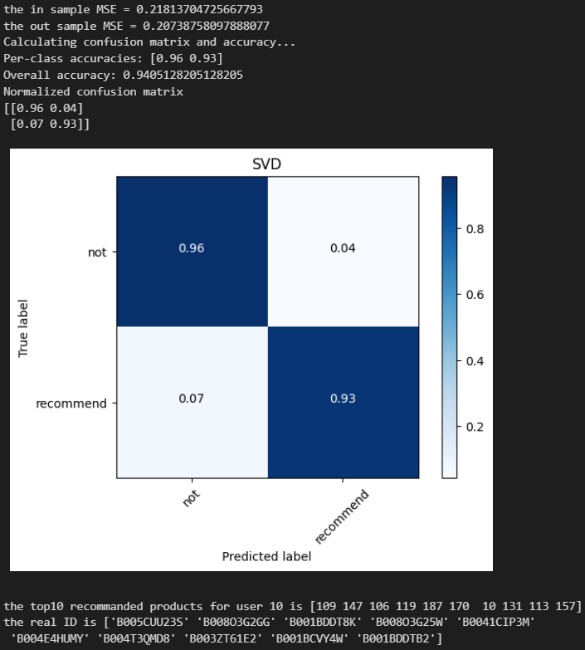
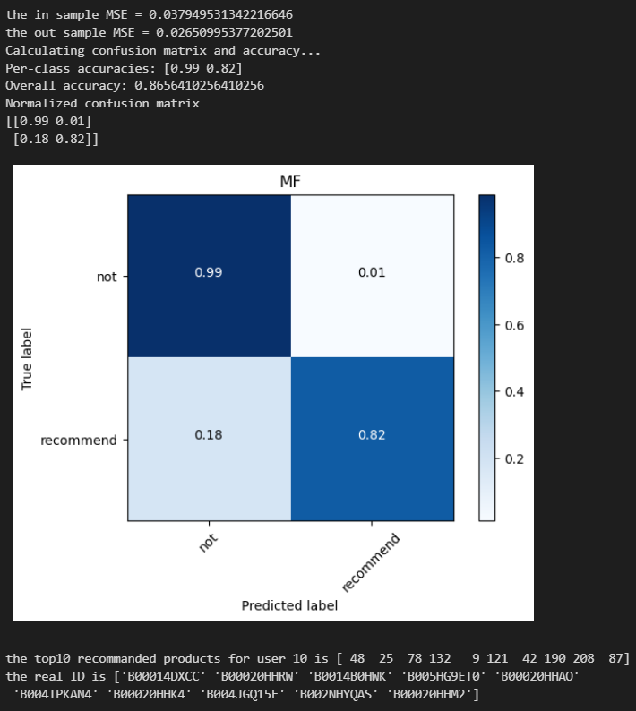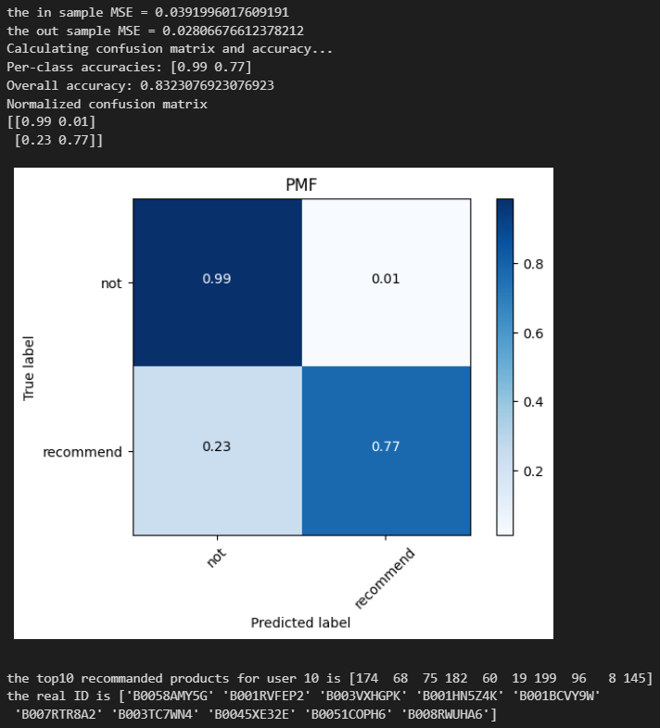

Figure 4: Confusion Matrix of (i) Random Forest Regressor (ii) Single Value Decomposition (SVD) (iii) Matrix Factorisation (iv) Probabilistic Matrix Factorisation

5 Conclusion
In summary, the project focused on customer behavior analysis, leveraging the Amazon food reviews dataset to conduct a thorough comparison of recommendation systems. Various algorithms, including the Random Forest Regressor, Distance-based model with Cosine Similarity, Single Value Decomposition (SVD), Matrix Factorization, Probabilistic Matrix Factorization, Convolutional Neural Network (CNN), Stacked LSTM (Long Short Term Memory), and Attention-based Autoencoder, were evaluated using MSE, confusion matrices, and accuracy metrics. Through this analysis, it became evident that SVD and Matrix Factorization emerged as standout performers, displaying strong predictive capabilities with low MSEs and high accuracies. Moreover, the Stacked LSTM and Attention-based Autoencoder showcased impressive accuracy, indicating their potential for precise recommendation in customer behavior analysis. These results emphasize the significance of employing sophisticated machine learning methodologies to comprehend and forecast customer behavior accurately, thereby empowering better decision-making processes within the e-commerce domain and recommendation systems landscape.

References
1. | J. McAuley and J. Leskovec. From amateurs to connoisseurs: modeling the evolution of user expertise through online reviews. WWW, 2013. The link: https://www.kaggle.com/snap/amazon-fine-food-reviews/data
2. | Salakhutdinov and Mnih, Probabilistic Matrix Factorization, NIPS 2008.The link: http://papers.nips.cc/paper/3208-probabilistic-matrix- factorization.pdf
3. | Mohammad Khoshneshin, Collaborative Filtering via Euclidean Embedding, RecSys '10 Proceedings of the fourth ACM conference on Recommender systems.The link: https://dl.acm.org/doi/10.1145/1864708.1864728
4. | Koren, Yehuda, Robert Bell, and Chris Volinsky. "Matrix factorization techniques for recommender systems." Computer 42.8 (2009).
5. | Pujahari, D.S. Sisodia, Item feature refinement using matrix factorization and boosted learning based user profile generation for content-based recommender systems, Expert Syst. Appl. 206 (2022) 117849, https://doi.org/10.1016/J. ESWA.2022.117849.
6. | Lekshmi Priya, T., Sandhya, H. (2021). Matrix Factorization for Recommendation System. In: Chiplunkar, N.N., Fukao, T. (eds) Advances in Artificial Intelligence and Data Engineering. AIDE 2019. Advances in Intelligent Systems and Computing, vol 1133. Springer, Singapore. https://doi.org/10.1007/978-981-15-3514-7_22
7. | S. Xu, H. Zhuang, F. Sun, S. Wang, T. Wu, and J. Dong, “Recommendation algorithm of probabilistic matrix factorization based on directed trust,” Computers & Electrical Engineering, vol. 93, p. 107206, Jul. 2021, doi: https://doi.org/10.1016/j.compeleceng.2021.107206.
8. | C. Reddy and T. Fernandez, “Movie Recommendation Systems Using Random Forest And Comparing Prediction Accuracy With Section A-Research paper Naïve Bayes Based Collaborative Filtering Eur,” Chem. Bull, vol. 2023, no. S1, pp. 4425–4433, Available: https://www.eurchembull.com/uploads/paper/1f24368aa70393cd9767945278f705eb.pdf.
9. | A. Agarwal and Senthilkumar, “RESUME RECOMMENDATION SYSTEM USING COSINE SIMILARITY.” Accessed: Apr. 29, 2024. [Online]. Available: https://www.irjmets.com/uploadedfiles/paper/issue_4_april_2022/20627/final/fin_irjmets1649235369.pdf
10. | A. K. Dey, V. K. Chauhan, P. K. Singh and P. Choudhury, "LSTM-Based Top N Recommendation System using Cognitive Data," 2022 11th International Conference on System Modeling & Advancement in Research Trends (SMART), Moradabad, India, 2022, pp. 93-98, doi:10.1109/SMART55829.2022.10046838.
11. | Q. Li, X. Zheng, and X. Wu, “Neural Collaborative Autoencoder,” arXiv.org, Dec. 19, 2018. https://arxiv.org/abs/1712.09043 (accessed Apr. 29, 2024).
12. | S. Chen and M. Wu, “Attention Collaborative Autoencoder for Explicit Recommender Systems,” Electronics, vol. 9, no. 10, p. 1716, Oct. 2020, doi: https://doi.org/10.3390/electronics9101716.  ‌

